**Discussion Forum Directions for Students**

To add to the discussion forum, click Add a new discussion topic.

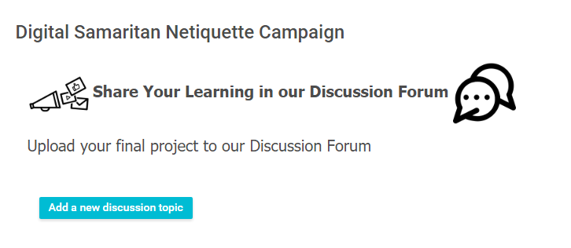

In the Subject area**, create a title** for your series of posters.

To be able to change the font, click on the editing box (beside Message).

In the larger text area, state the members of your group or partnership.

Explain the **goal of your campaign** and what you hope to achieve. If you have created a series of posters in an online platform like Adobe Spark (Post, Page or Video), you can just **share the link in the post**. If you have posters, be sure to link **all the images**. All other images can be uploaded or just drag and dropped (see below).

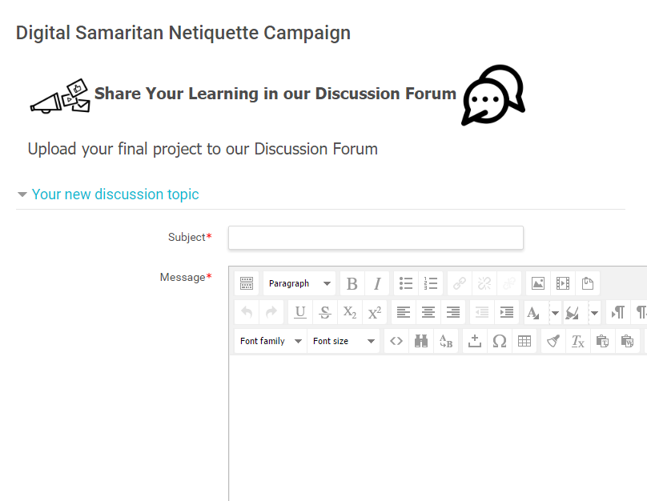

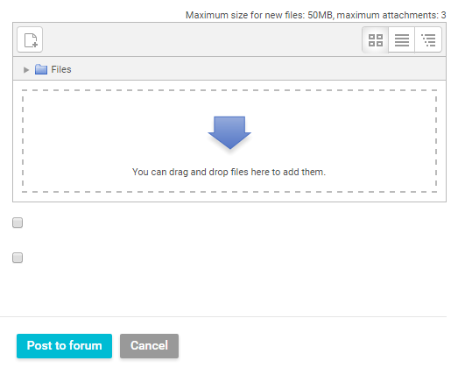Drag and drop pictures or videos into the box if created via an app. Then click “**Post to Forum**”.