**Flipgrid Instructions for the Samaritans on the Digital Road Course**

Go to Flipgrid.com

Add the Grid Code, which is **digsam2017**

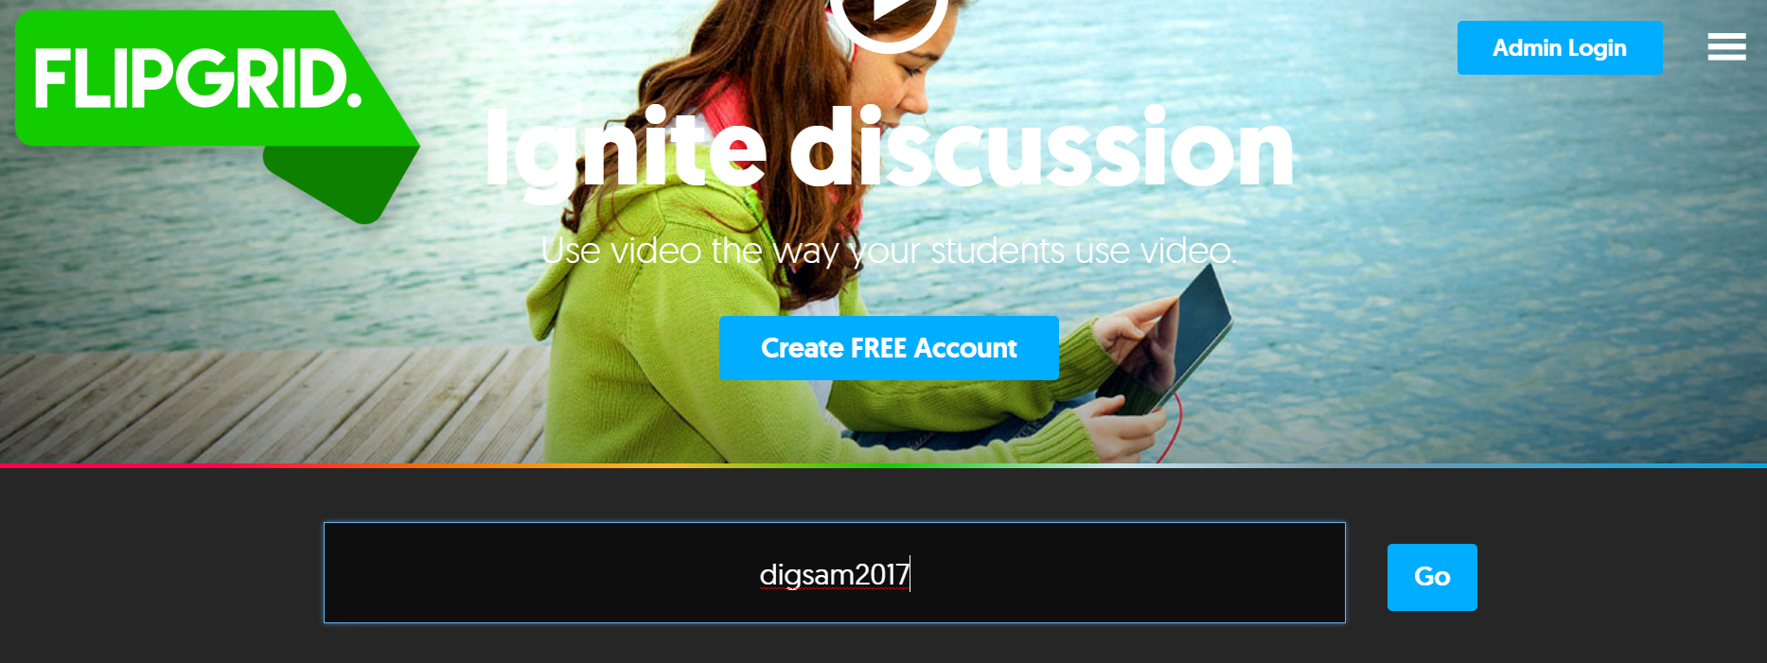

The grid is password protected, enter the password which is: **faith**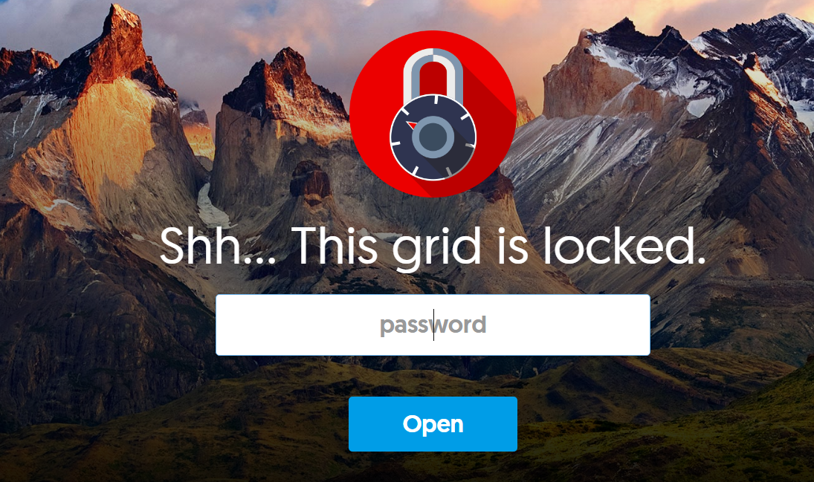

Once your grid is opened, click on the **question box**. Make sure that you have chosen the correct topic for the module.

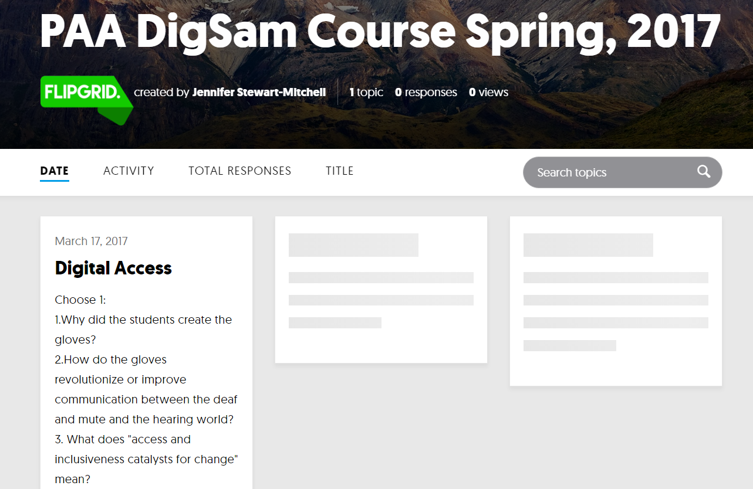

To Add a Response, click on the **large green plus**. 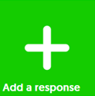

You will have **2 minutes** to record your response. If you need to, you can record more than one response to a question.

*Try to record with a headset or in a space that is not too distracting or loud.*

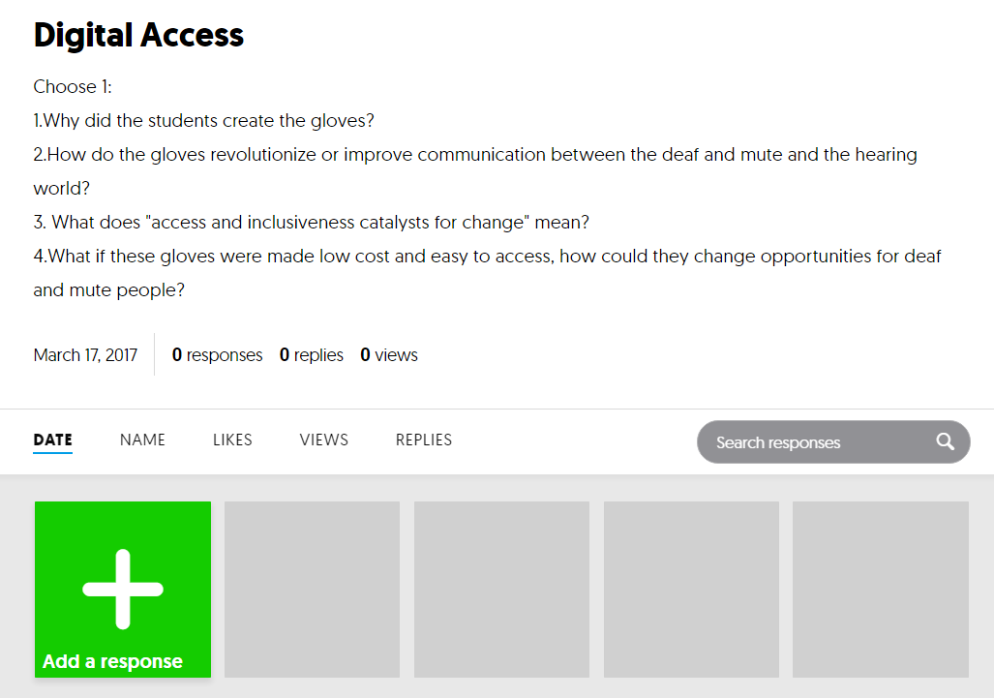

Press the **red button** and record your message. Note that it will count you down.

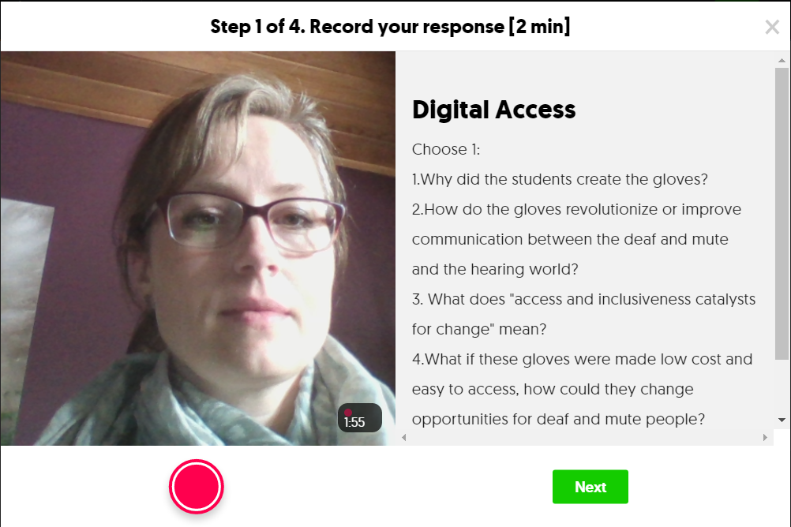

Review your recording. If you need to redo it, then go ahead! If your are happy with it, then click **next**.

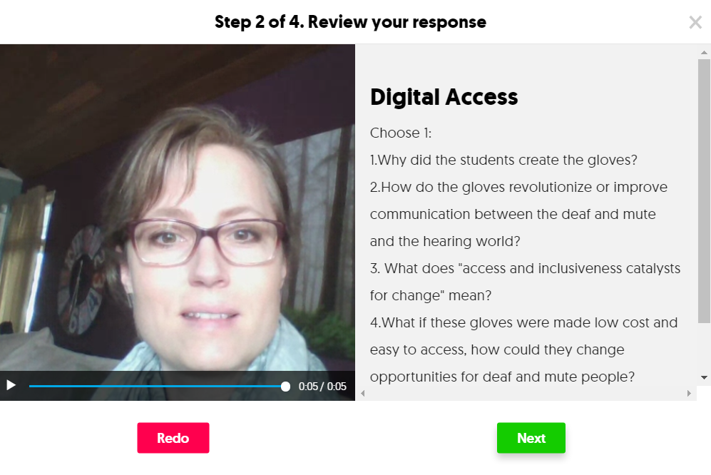

After you record, take a picture of yourself, which will be seen as a thumbnail (small) image. So that other members of our group may recognize you.

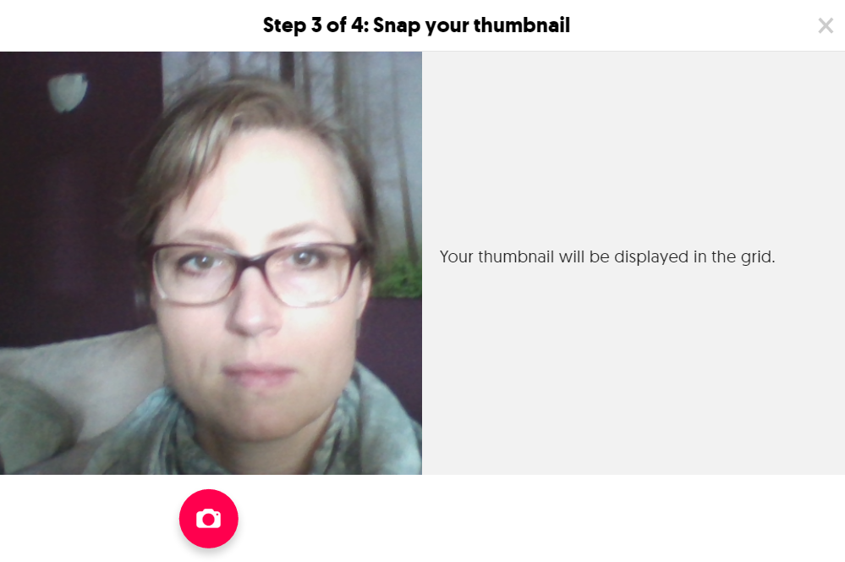

Finally enter your first and last name (or your last initial) and press **Submit my video**.

