**Flip Grid**



**Step #1**

**Step #2**

flipgrid.com

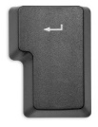

Enter

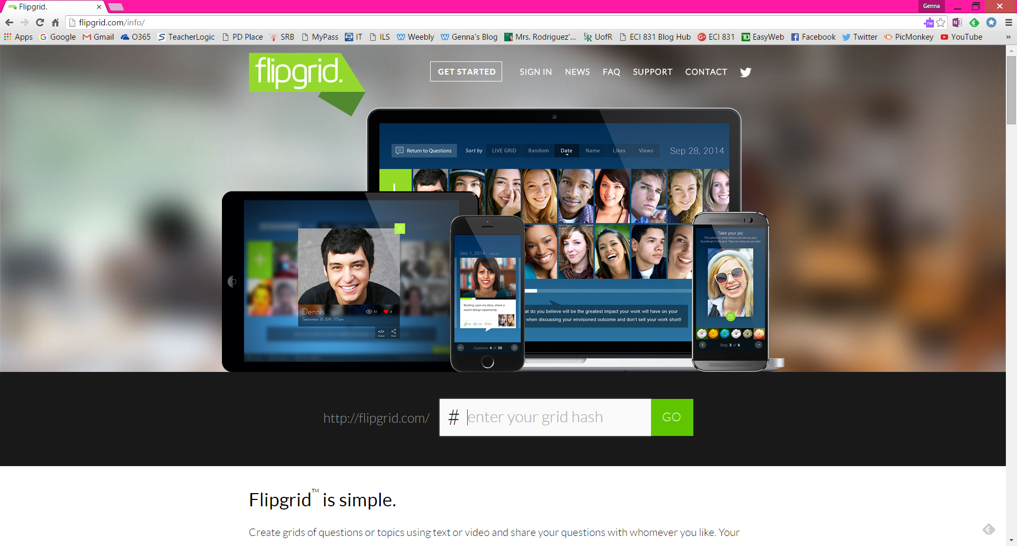

**Step #3**

Enter the # your teacher gives you. Once in, you will be asked to type in a password. See your teacher for the password.

**Step #4**

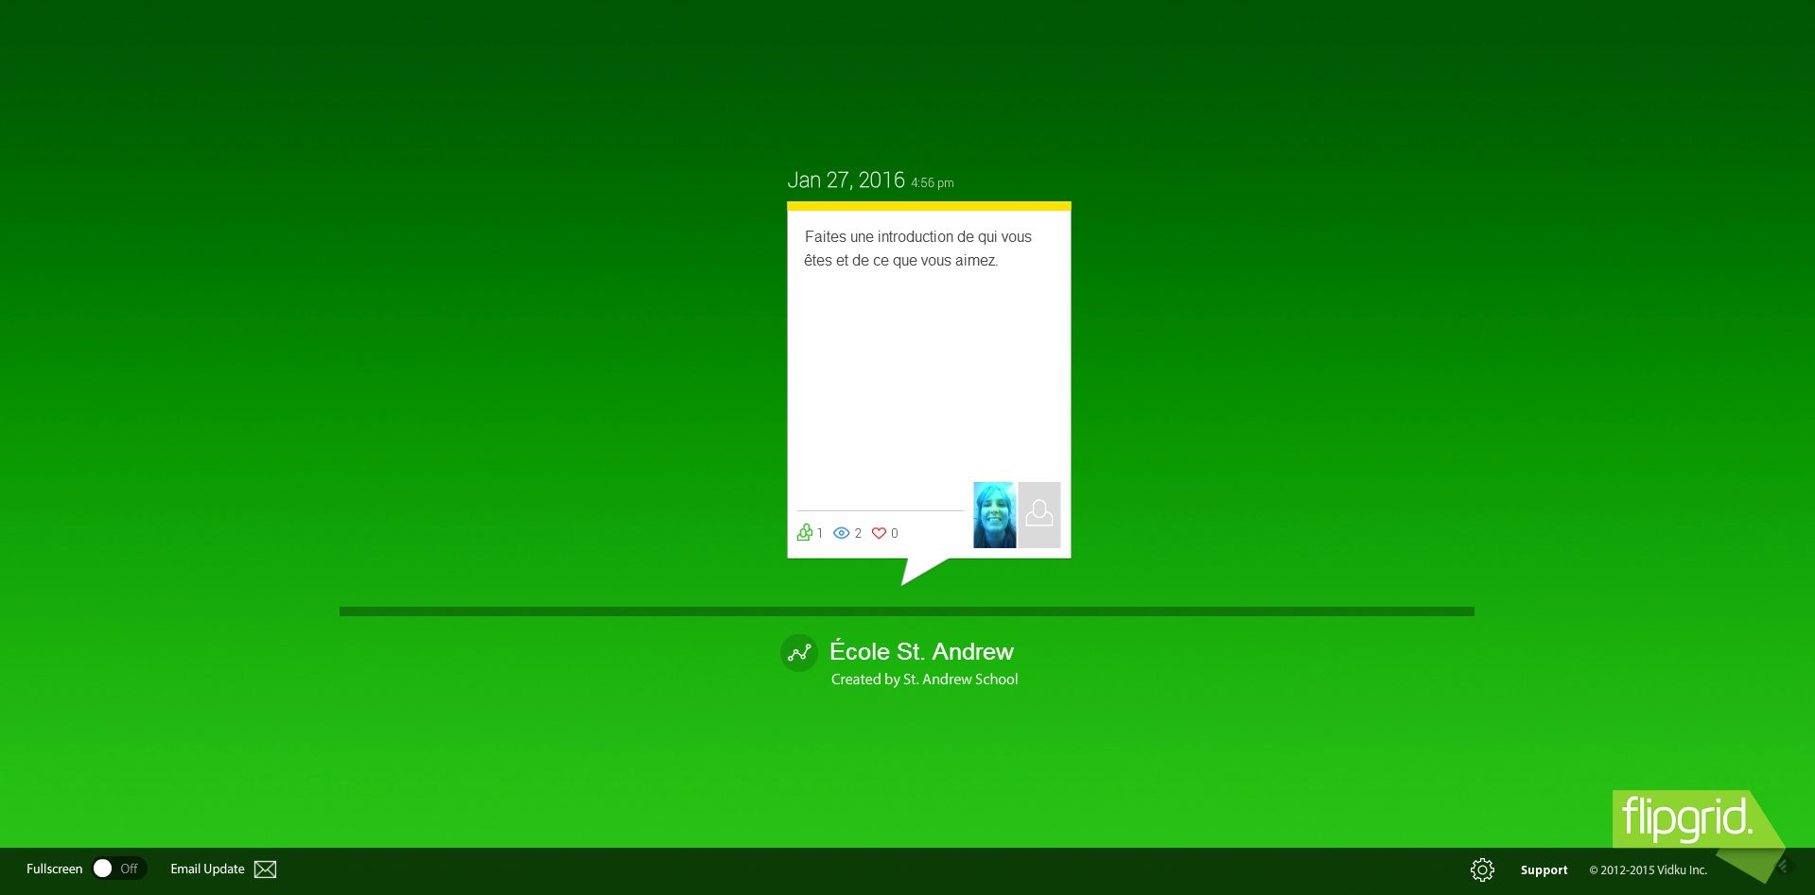

**Step #5**

Click on the correct question your teacher has posted.. It may be either a video question to listen to or a written question.

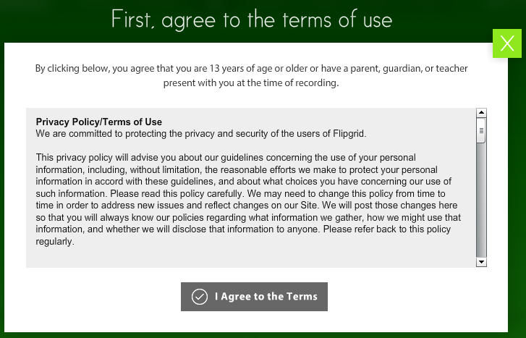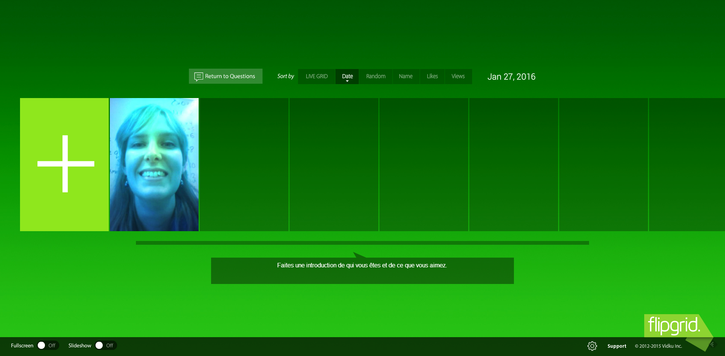

**Step #7**

**Step #6**

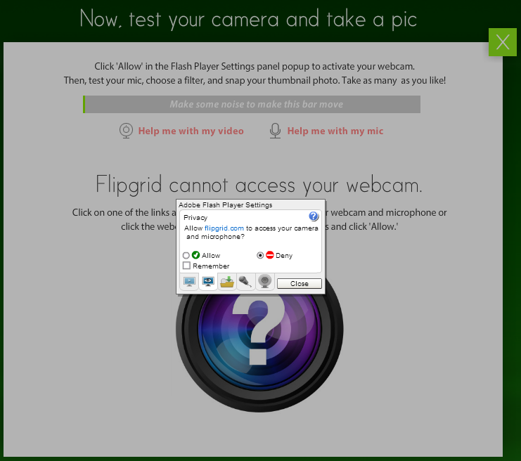

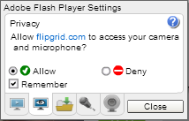

**Step #8**

**Step #9**

**Step #10**

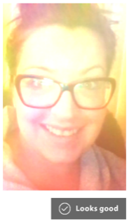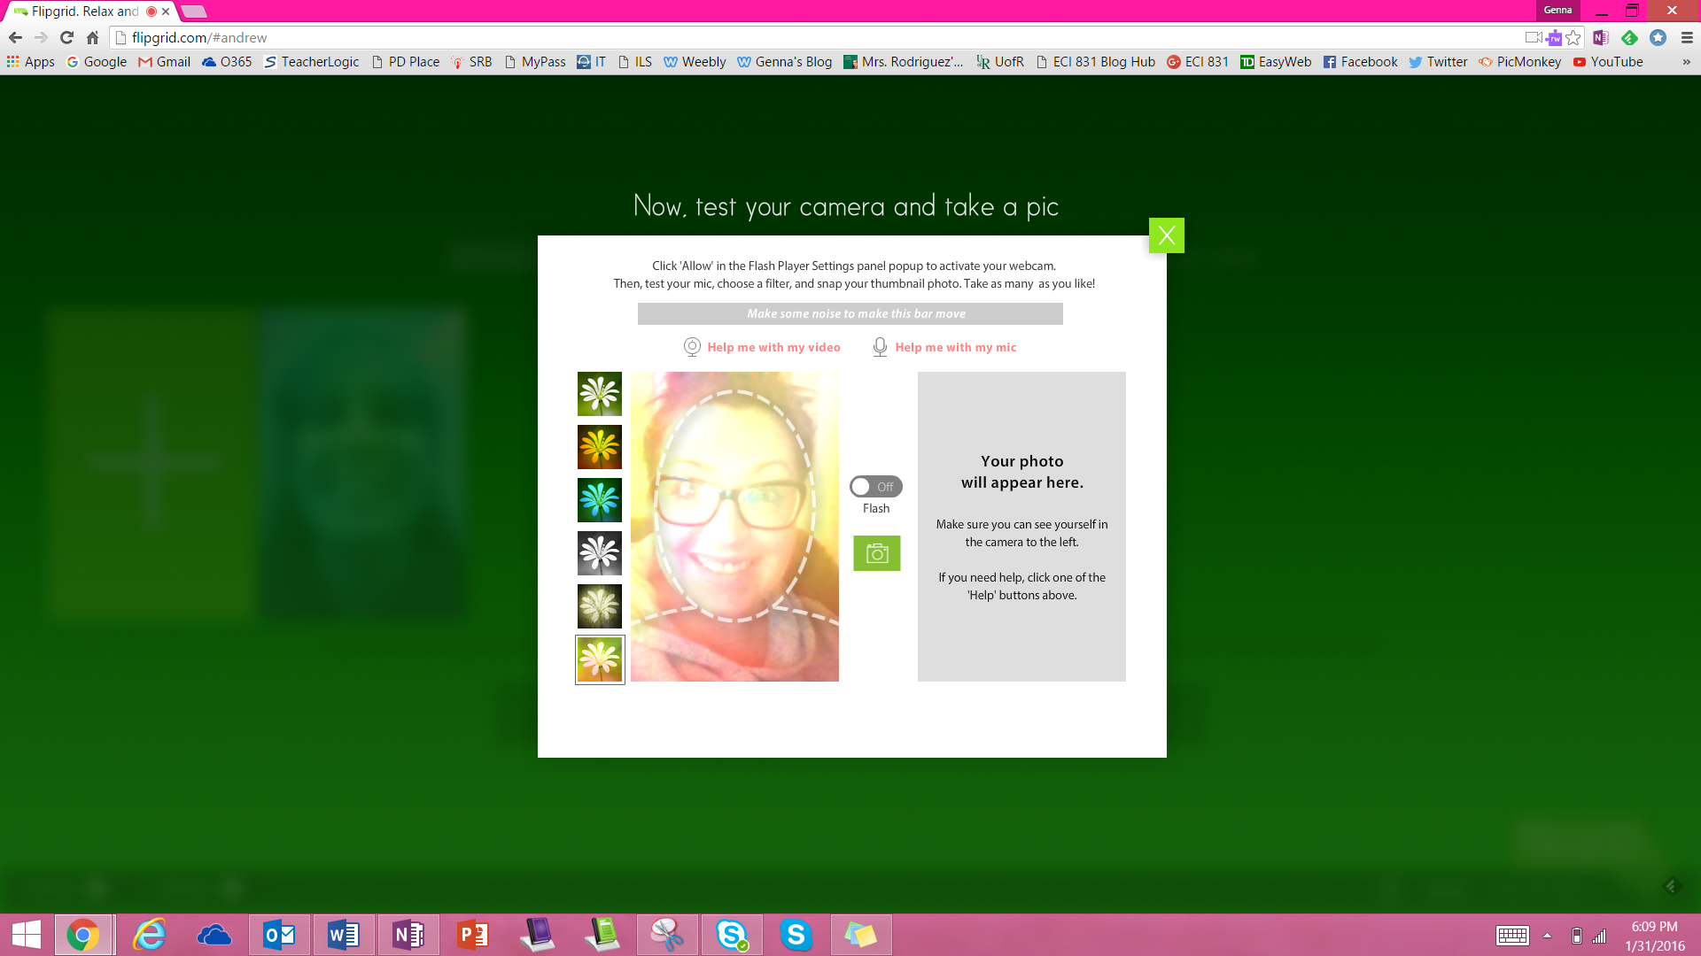

**\*\*Smile!\*\***

**Step #12**

**Step #11**

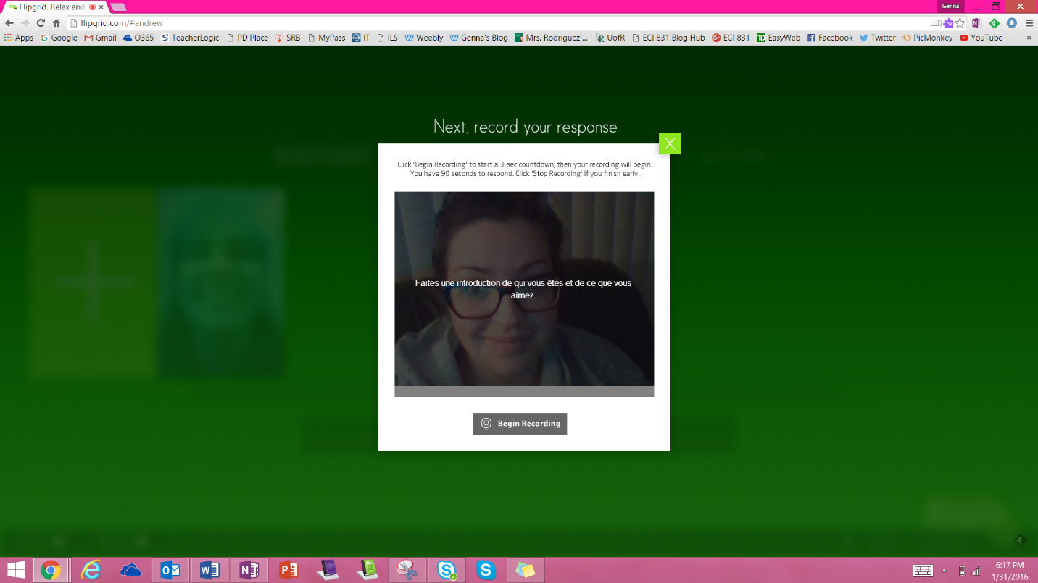

**Step #13**

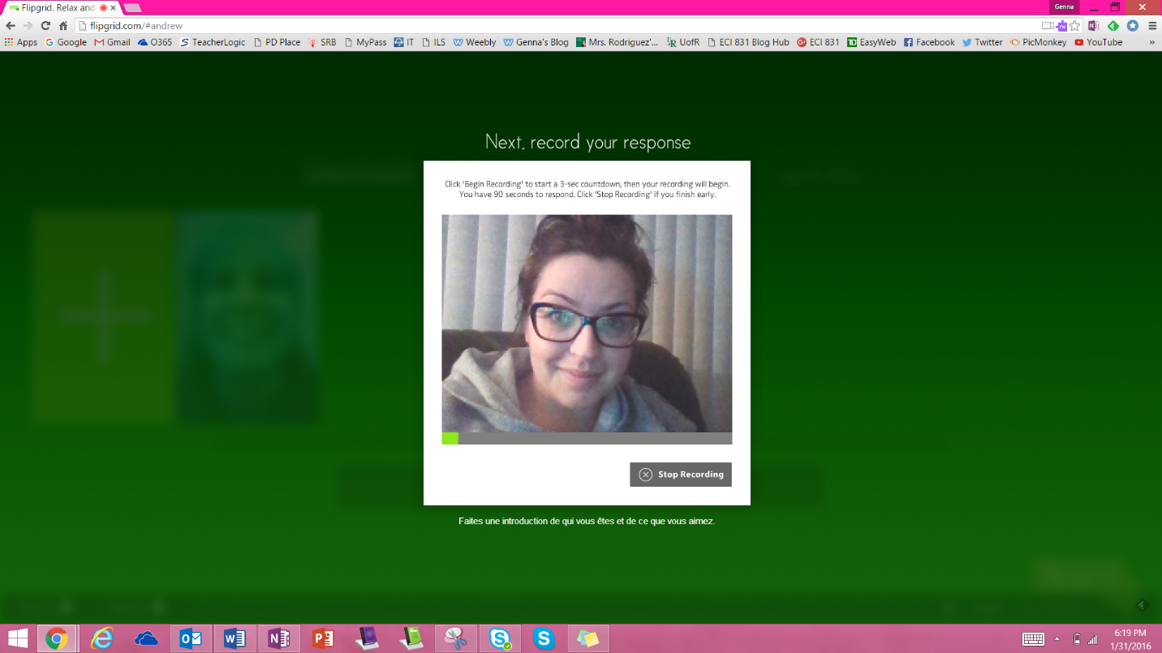

*Stop recording your message when you are done.*

**Step #14**

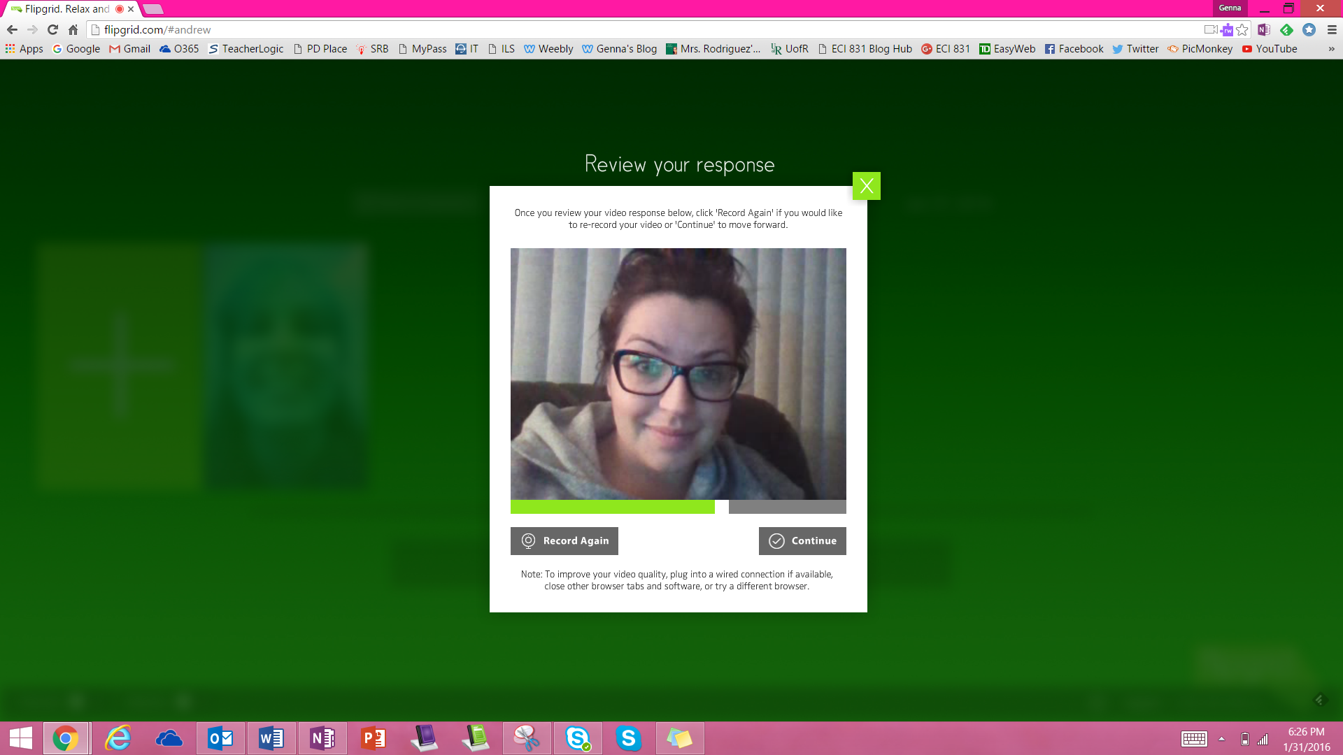

**Step #15**

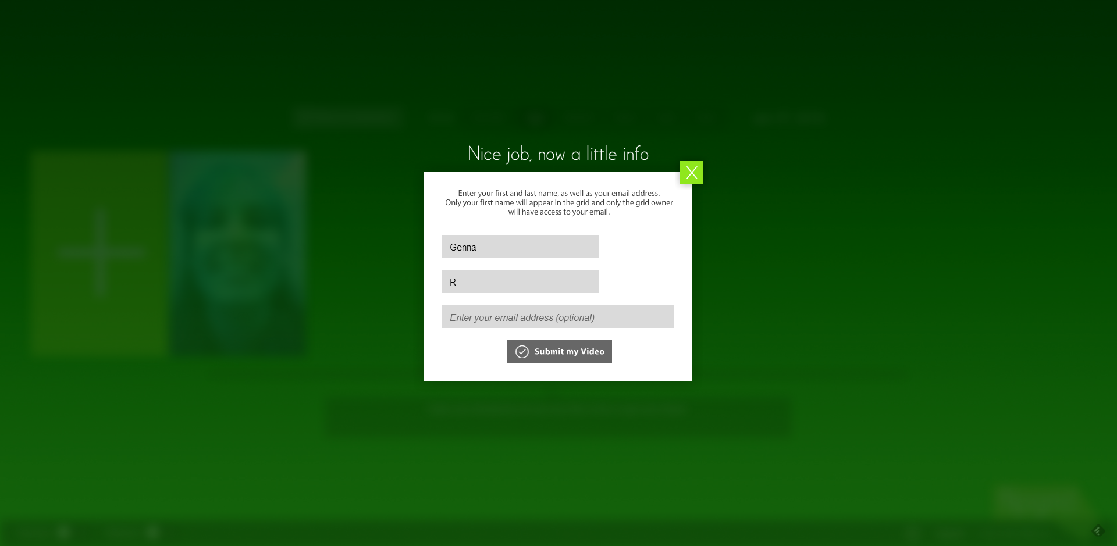

**Step #18**

**Step #17**

*Last name*

**Step #16**

*First name*